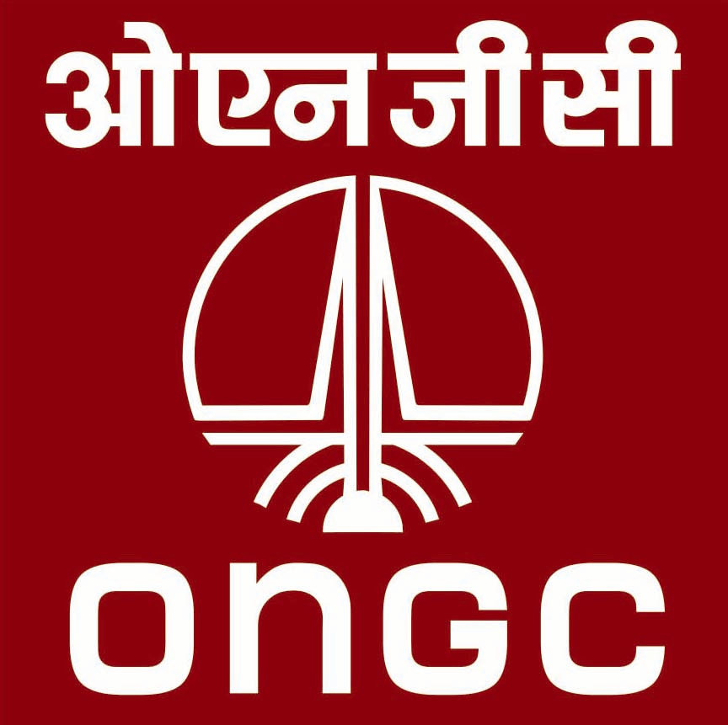 | Oil and Natural Gas Corporation Limited  Well Services, Ahmedabad Asset

Advertisement No. AMD /CONSLT-2023(1)

ONGC Ahmedabad Asset invites application from experienced personnel retired from ONGC from Production / Drilling disciplines to apply for Junior Consultants and Associate Consultants (for posting as competent persons in shift / general shift on charter hired and O&M operated Work over Rigs of Ahmedabad Asset for supervision of Work-over Operations) on contractual basis for a period of two years as per following details:

- Details :
Sl.  No. | Post | No. of posts & Discipline(s) | Required Experience
1. | Junior Consultant  (E1 to E3 level) | 18(Production discipline) | Retired ONGC executives who retired at E1 to E3 level for Junior consultant posts & at E4 to E5 level for Associate consultant posts from Production/Drilling discipline with at least 5 years of experience in Work Over/Drilling field operations.  (*In case of non-availability of E4 to E5 level candidates in required numbers, E6 level candidates will also be considered for engagement with capping of remuneration to E5 level based on their consent.)
2. | Associate Consultant  (E4 to E5)  *E6 level Executives can also apply. | 38 - (Production discipline)

Note: Nos. of posts may vary depending on availability and operational requirement of ONGC.

- Monthly Compensation package/ Remuneration / Emoluments (including GST to be borne by consultants):

- For Junior Consultant (E1 to E3):

Tenure | Monthly Honorarium  (Rs) | Conveyance Reimbursement (Rs/Month) | Reimbursement for office at Residence (Secretary, peon etc.) (Rs/Month) | Monthly charges on communication facilities | Total Compensation (Rs/Month)
1st year | 27000/- | 6500/- | 6500/- | 2000/- | 42000/-
2nd year | 28350/- | 6500/- | 6500/- | 2000/- | 43350/-

- For Associate Consultant (E4 & E5) :

Tenure | Monthly Honorarium  (Rs) | Conveyance Reimbursement (Rs/Month) | Reimbursement for office at Residence (Secretary, peon etc.) (Rs/Month) | Monthly charges on communication facilities | Total Compensation Rs/ Month)
1st year | 40000/- | 13000/- | 13000/- | 2000/- | 68000/-
2nd year | 42000/- | 13000/- | 13000/- | 2000/- | 70000/-

- Age Criteria: Less than 65 years of age as on 22 February 2023.

- Scanned copy of ONGC Identity Card (both sides) to be submitted by the candidates along with application/ Bio Data form.

- Scanned copy of application in the attached format along with the required documents may be sent to well services department to the following email/address:

- AMDWSPC@ONGC.CO.IN
- Eligible candidate(s) can also submit the applications in person at Contract Cell, Room No-131B, 1st floor, Avani Bhavan , ONGC, Ahmedabad Asset, Gujarat.

- Last date of receipt of application: 16 March 2023
- Date & Venue for written test and personal interaction and other details:
- Venue : At ONGC, Ahmedabad
ii) Date & other details: To be intimated to the shortlisted candidates in due course of time through email.

- Selection Criteria:

The following eligibility/ selection criteria have been proposed:

- The Selection board will adopt the following selection criteria for awarding the marks to the candidates for selection :-

Criteria | Full Marks
- Written Test | 80
- Interaction/ interview | 20
Total Marks | 100

- The written test shall be conducted in pen paper format. Question paper will be bilingual (English and Hindi) having Objective Type -Multiple Choice Questions. Total of 20 questions to be answered in 60 minutes duration. Each question shall carry 4 marks and there will be no negative marking for wrong answers.
- Qualifying marks in written test will be 28 (out of total marks 80), i.e 35% of total marks. Candidates qualifying the written test will be shortlisted and called for Interaction/Interview.
- Qualifying marks for Interaction/Interview will be 12(out of total marks 20), i.e 60% of the total marks.
- Offer of engagement will be issued to the selected candidates as per overall merit.

- No TA/DA/Accommodation shall be paid for written test/Interview.

- Period of Engagement: The engagement shall be purely on contract basis for a period of 02 (two) years from the date of joining. Engagement on contract basis will be subject to medical fitness by ONGC Medical Authority as per mines rules 1955.

- Other Terms and conditions of the engagement includes but not limited to following:
- He/ She will not be eligible for any additional Benefits/Allowance/ Facilities/Incentives etc. as admissible to regular/tenure employee of the Corporation.

- Engaged personnel shall be required to work in any charter hired/ O&M operated work over rigs operating in Ahmedabad as competent person in shift duty/ general shift duty. Duty pattern may also change at the discretion of Well Services management. Rest period shall be provided in line with Mines rules.
- ONGC shall have the right to cancel the engagement at any time without assigning any reason thereof. However, in the normal course, engagement may be terminated from either side, without assigning any reason, by giving one month’s notice.
- The engaged personnel will not have any financial power.
- The engaged personnel will have to make his/her own arrangements of stay in Ahmedabad.
- MHA guidelines in respect of Covid-19 in vogue at the time of engagement and during the tenure will be applicable.
- He/ She will have no right to claim for regular employment in ONGC later, by virtue of this contractual engagement.
- The selected candidate will have to sign an agreement/contract with ONGC for the prospective period.
- Terms and conditions of this engagement shall be subject to change(s) from time to time based on Company’s latest policy.
- 80% of the monthly honorarium along with the reimbursement towards conveyance and expenses towards office at residence would be paid on monthly basis. The remaining 20% of the monthly honorarium shall be paid after assessment of the performance at the end of the engagement period and completion of assigned tasks.
- Self-Certification towards conveyance and expenses towards office at residence to be submitted on monthly basis for reimbursement.
- The reimbursement of Mobile Bill up to maximum ₹ 2000.00 per month shall be made upon submission of bill/invoice.
- Payment shall be on the basis of actual duty performed during the period of engagement.

- Roles and responsibilities during duty/ tenure:

The Consultant shall be posted in shift duty pattern and shall be responsible for complete supervision of all activities associated with Work Over operation such as:
- Adequate inspection of the installation and the equipment thereof;
- A thorough supervision of all operations at the installation;
- The installation, running and maintenance, in safe working order, of all machinery in the mine;
- To enforce requirements of Oil Mines Regulations, Compliance of Standard Operating Procedures (SOPs), Statutory guidelines and Mines Act.
- Regular update of QHSE documentation.
- Site inspection and supervision of site preparation, rig deployment at site, smooth execution of work over operations in co-ordination with Installation Manager and other departments, preparation of pipe tally and completion report etc..
- Any other responsibilities as assigned by Installation Manager required as per DGMS and other statutory authorities.
- Maintaining daily activity report and submit the same to Installation Manager.
- Duties of consultant working as competent person as per Regulation 33 of OMR-2017:
- Every competent person shall be subject to the orders of superior officials and shall perform his duty assigned to him in accordance with the provisions of the Act and of the regulations or the orders made thereunder.
- Competent person shall not
- Depute another person to perform his work without the approval of ONGC.
- Absent himself without having previously obtained permission from such official for the period of his absence or without having been relieved by a duly competent person; and
- Without permission from such official, perform during his shift, any duties other than those for which he has been appointed.
- The competent person shall, on the occurrence at his place of work any hazardous condition, take prompt corrective measures to eliminate the hazard.

